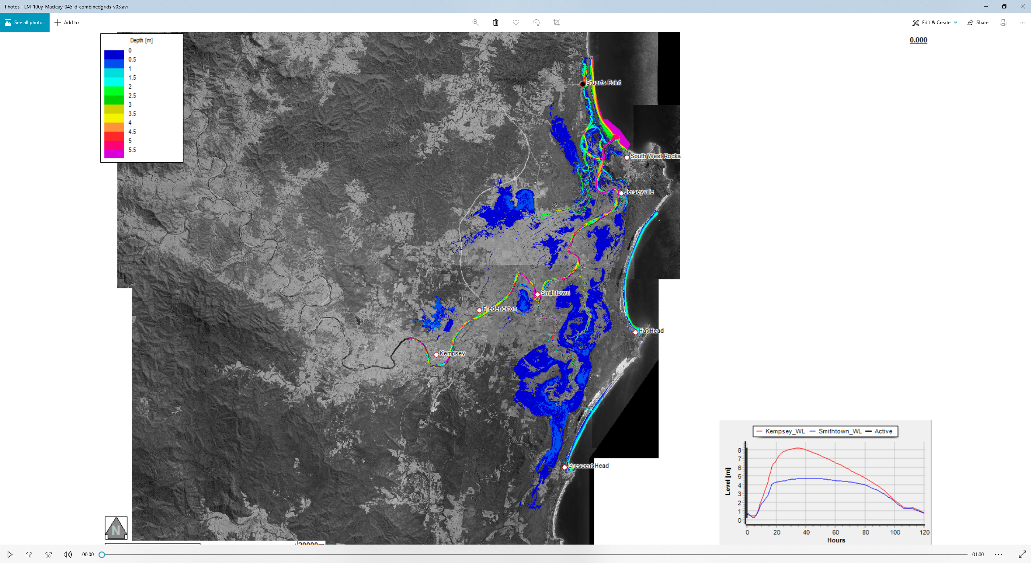
For “Design” Flood Events ponding in the floodplain storage zones has been considered to have occurred from pre-storm precipitation
Key Reference Point Locations:
- Kempsey Traffic Bridge Gauge
- Smithtown Gauge
Flood Level in “m AHD”
Vertical black line scrolls across as time in simulation indicator
Floodwater Depth Indicator (m) above ground / river bed level

This particular flood event movie takes 1.00 minutes to play and simulates flood behaviour for 120hrs
The video animation will automatically play using the device (PC/Laptop) default media player program. The movie can be paused at any time by clicking on the play button

